**Practical No: 05**

**Aim: Create and design a Post in WordPress**

Step 1: login as Admin at WordPress.

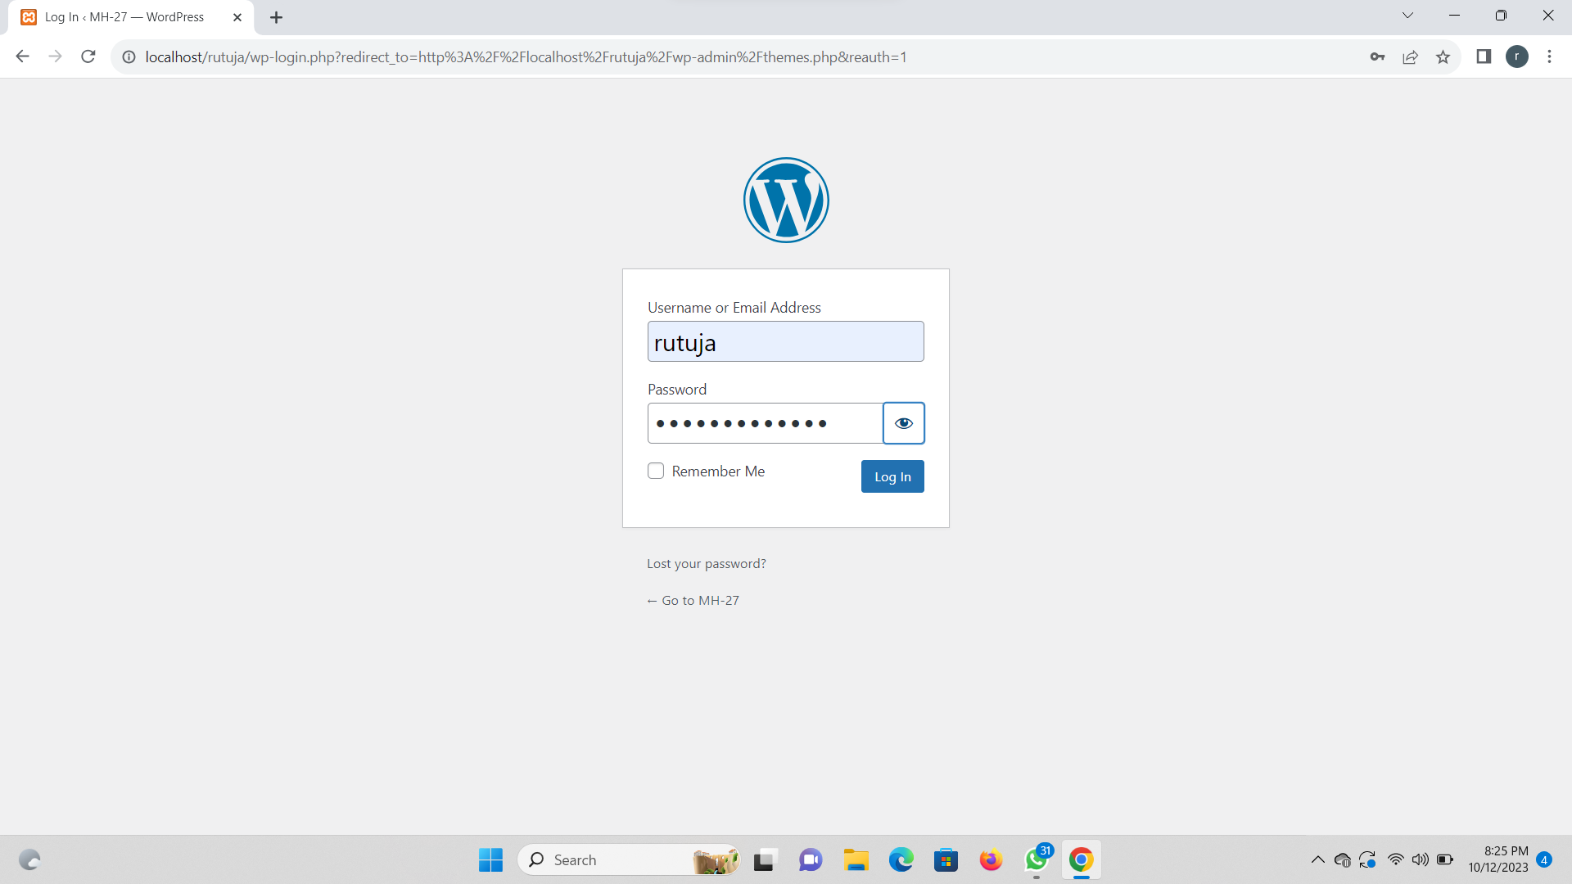

Step 2: Select pages option and add new page.

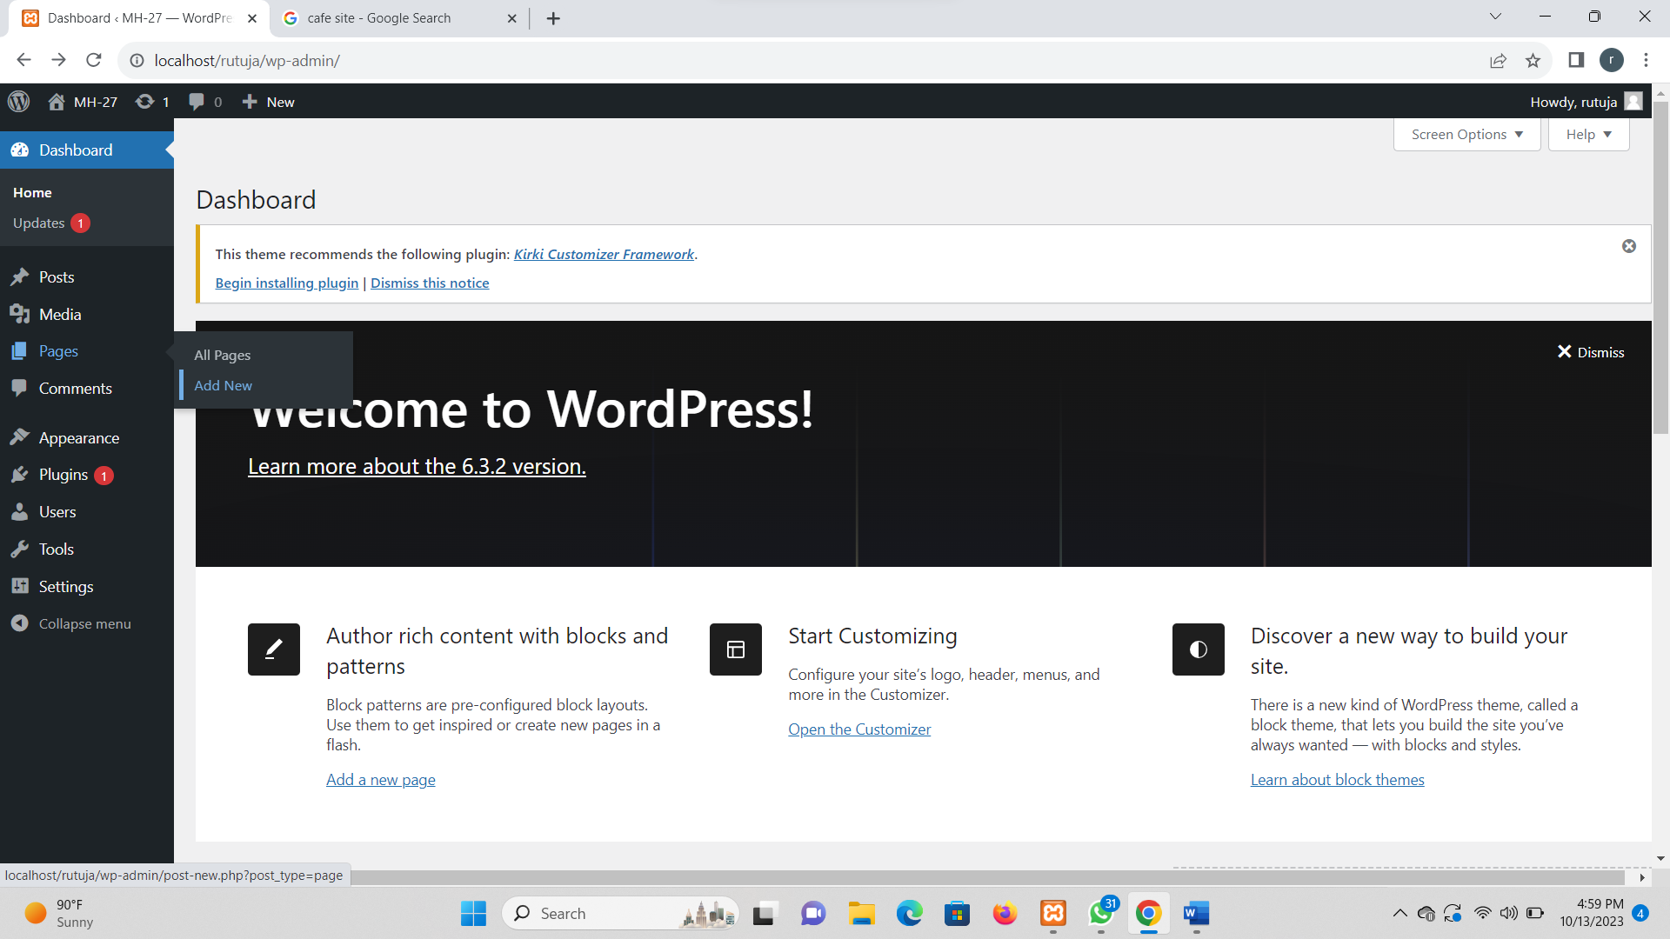

Step 3- To add text, you just click and type.



Step 4: Change your blog looks.

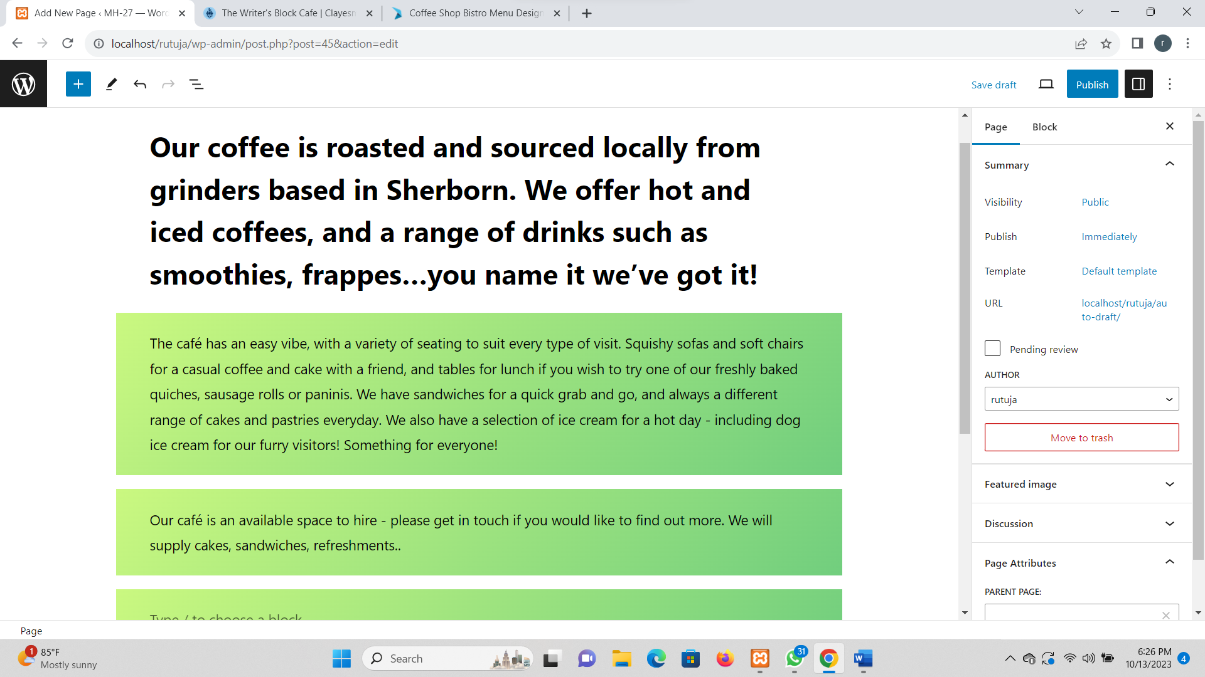

Step 5: Add functionality to your blog.

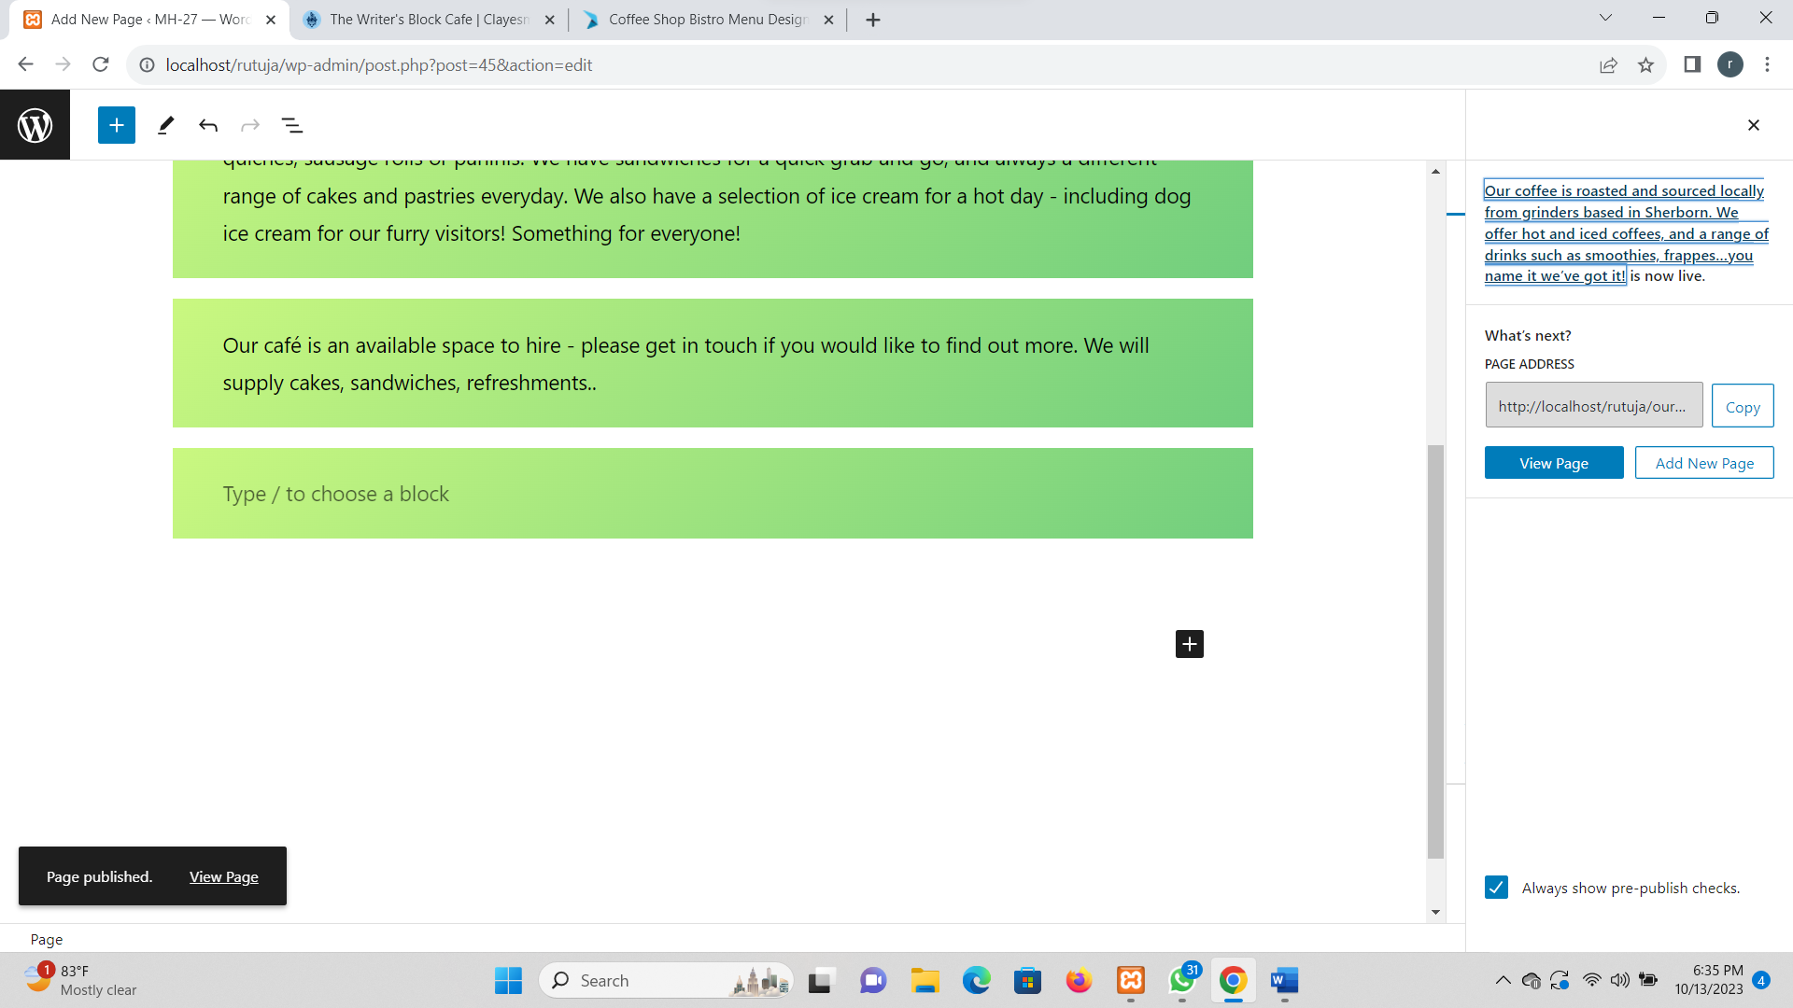

Step 6: Front End (Blog Created).

